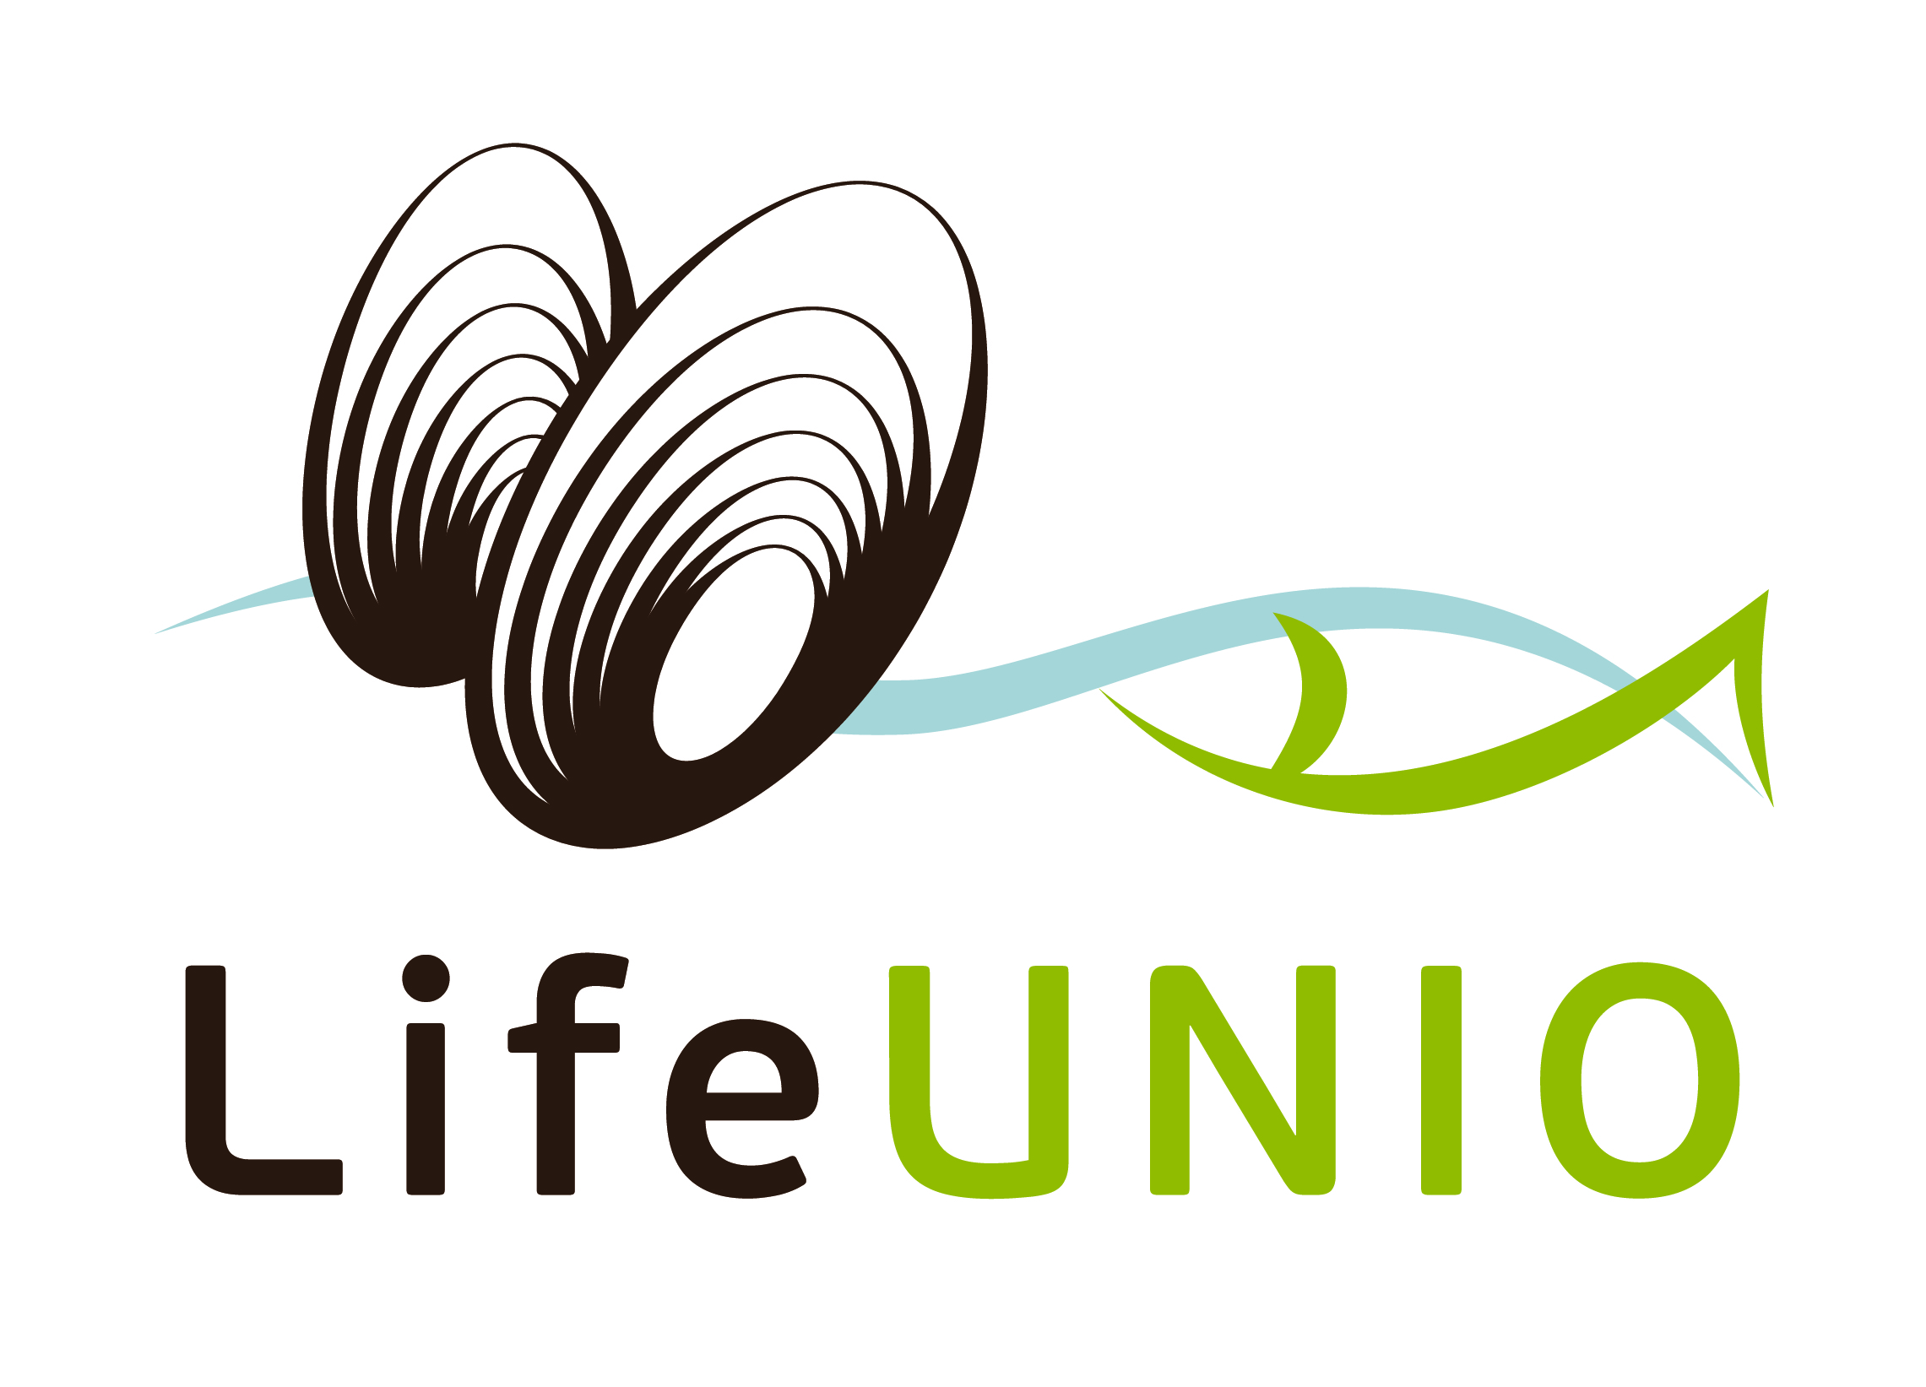 | Restoration of Unio crassus rivers in the Luxemburgish Ardennes  LIFE11 NAT/LU/857  2nd International seminar on the rearing of unionoid mussels  Tuesday 24th November – Thursday 26th November 2015  Clervaux (Luxembourg) |   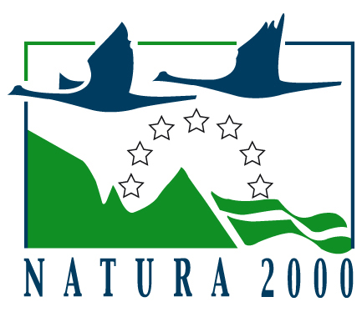

Registration Form

- If you want to make a contribution please use the Abstract Submission Form
- Please note that the deadline for the abstract submission is 4th September, 2015
- Please send this form as a “word” attachment to the e-mail address: f.thielen@naturemwelt.lu
- Please note that the last registration date is: October 30, 2015

Please fill in the spaces using your word processor
First name: | Last name:
E-mail address: | Phone number:
Address: | Country:
City: | Field of study:
Affiliation:

