 | Restoration of Unio crassus rivers in the Luxemburgish Ardennes  LIFE11 NAT/LU/857  2nd International seminar on the rearing of unionoid mussels  Tuesday 24th November – Thursday 26th November 2015  Clervaux (Luxembourg)  Abstract Submission Form | 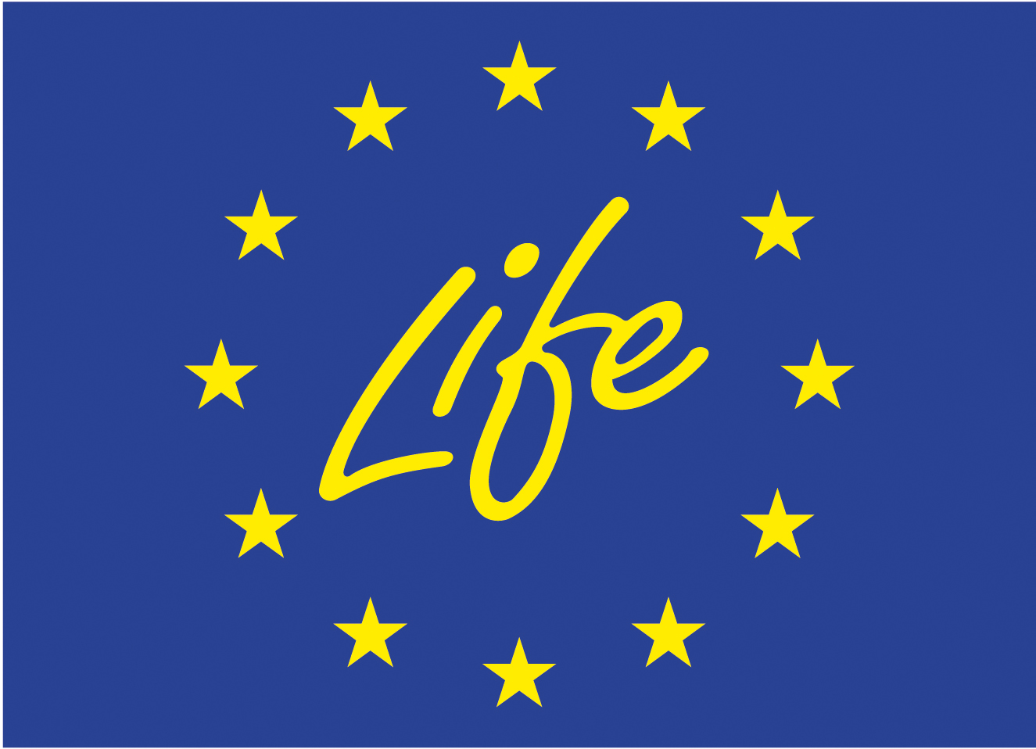  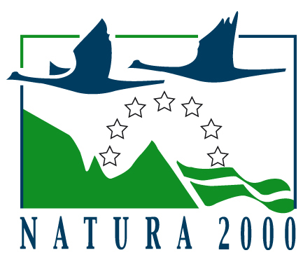

- Please note that the deadline for the abstract submission is September 4th, 2015.
- Please send this form as a “word” attachment to the following e-mail address: f.thielen@naturemwelt.lu

Presentation (please check the appropriate box):
Oral Poster

Please fill in the spaces using your word processor
First name of the first Author: | Last name of the first Author:
E-mail address: | Phone number:
Address: | Country:
City: | Field of study:
Affiliation:

Title of Abstract:

Corresponding Author’s name: | Corresponding Author’s address:
Corresponding Author’s e-mail: | Corresponding Author’s phone number:
Corresponding Author’s fax number: | Affiliation:
List of all Authors:

If oral presentation, audiovisual requirements:
PowerPoint Other

Notes to the Authors (see example below):

The abstract should be typed in English, single space. The length could be maximum 500 words (Title, Authors and Affiliations included). Please use the font Times New Roman, 11 point font size. See example below.

- Title: written in capital and lower-case letters; in bold, 16 point font size and left alignment. Leave a single space line between title and Author’s names.

- Name of the Authors: written in bold, 11 point font size and left alignment (complete surname and first name(s) abbreviated with initial(s), separating all Authors with “commas” (not with “and” or “&”). Add numeric super indices for Affiliation.

- Affiliation: separated from the names of the Authors by a single space line; according to numeric super indices noted in Authors; separating centres with “semicolon”; written in italic, 11 point font size.

- Text: separated from affiliation by a single space line; justified text format is strongly recommended; names of species and genus must be in italic type. The text must include the contents of objectives, material and methods, results, discussion and conclusions, but without using subheadings. References could be indicated in the text without the title of the paper (i.e.: Mattiucci S et al, 2006, Parassitologia, 48: 351-352). Tables, plots and figures are not accepted.

- Acknowledgements: separated from the text by a single space line; use 11 point font size.

Please paste the abstract, including Title, Authors and Affiliations, replacing the example given in the rectangle and following the “Notes to the Authors” above.
Abstract (Example):

Morphological Abnormalities of Paradiplozoon homoion (Diplozoidae; Monogenea) as Indicators of Environmental Stress

Pecinkova M.^{1*}, Koubkova B. ¹, Vøllestad L. A.², Huml J. ³, Jurajda P. ³, Gelnar M.¹

¹ Department of Zoology and Ecology, Faculty of Science, Masaryk University, Brno, Czech Republic; ² Centre for Ecological and Evolutionary Synthesis, Department of Biology, University of Oslo, Oslo, Norway; ³ Institute of Vertebrate Biology, Academy of Sciences of the Czech Republic, Brno, Czech Republic
*corresponding author

Fish ectoparasites are in direct contact with both its fish host and the surrounding environment, and both the host quality and the water quality may influence the development of the parasite. The developmental stability of individuals is assumed to be influenced by environmental stress. Here, we study various indicators of developmental stability that may be useful indicators of habitat quality. We study the occurrence of morphological abnormalities in an ectoparasite and correlate that with the fluctuating asymmetry (FA) or the deviation from the morphological mean for its fish host. Fluctuating asymmetry is defined as the random deviation from the perfect bilateral symmetry and the presence of environmental or genetic stress during ontogeny reduces the efficiency of normal developmental processes, thus increasing the level of FA. A total of 100 gudgeon (Gobio gobio) individuals were collected in monthly samples of 20 individuals from Vlara stream (CR). Fish were surveyed for all eco- and endoparasites. The monogenean ectoparasites Dactylogyrus cryptomeres and Paradiplozoon homoion reached the highest values of abundance. About 25% of the collected individuals of P. homoion showed abnormalities of the attachment sclerites (e.g. size reduction of adult parasite clamps without changes in their sclerite structure, clamps with abnormal sclerites, rudimentary clamps). Abnormalities were not observed on other monogenean parasites. The proportion of abnormal P. homoion is high, indicating a stressful environment. To assess an estimate of developmental instability of the fish host we measured eight metric and nine meristic bilateral characters on the right and the left side of the fish. In general, there was no correlation between fish FA or individual departure from the morphological mean and the number of P. homoion or the proportion of P. homoion with abnormalities. There was, however, a significant relationship between number of abnormal P. homoion and the number of asymmetric meristic traits per individual fish. This study thus indicates that the presence of morphological abnormalities in P. homoion is not dependent on the fish quality as measured by FA and morphological variability.

We acknowledge the financial support by the Grant Agency of the Czech Republic (No. 524/04/1115) and by the Research Council of Norway

1 Please contact f.thielen@naturemwelt.lu if you need any other support.

